Deep Learning-Based Deepfake Detection for Social Media Content

A. ASSIGNMENT INFORMATION
Particular | Details
Department | Computer Science And Engineering
Programme | B.E - CSE
Course Code & Course Name | CSA 1711 – Artificial Intelligence
Academic Year / Batch | 2024 - 2028
Faculty Name | Dr. Krishna Kumer
Assignment Title | Deep Learning-Based Deepfake Detection for Social Media Content
Date of Issue | 03 – 09 – 26
Date of Submission | 03 – 09 – 26
Maximum Marks | 100
Course Outcome(s) – CO
Bloom's Taxonomy Level | L3 – Apply, L4 – Analyze, L5 – Evaluate, L6 – Create
SDG Mapping | SDG 9 – Industry, Innovation and Infrastructure; SDG 16 – Peace, Justice and Strong Institutions
Industry / Societal Relevance | Content moderation, digital forensics, misinformation reduction and trustworthy media

B. ASSIGNMENT PROBLEM / CHALLENGE
Synthetic facial media can be produced by changing a person's identity, facial expression or appearance inside an image or video. The resulting content can look realistic, and platform resizing or compression can make manual inspection even harder. The challenge is to build an automated screening system that can analyse facial evidence and decide whether the supplied media is more consistent with genuine or manipulated content.
The revised solution treats video as a sequence rather than a collection of unrelated images. A convolutional network extracts spatial information from each face, while a recurrent model studies how those representations evolve over time. This makes the approach different from a frame-only classifier and from simple vote-based aggregation.

B.1 Assignment Goals
- Apply deep learning and computer-vision concepts to a realistic media-authentication problem.
- Formulate functional, technical, performance, privacy and reliability requirements.
- Develop and compare candidate deep learning approaches.
- Implement a spatial-temporal detection pipeline.
- Validate the model using quantitative metrics and controlled test cases.
- Explain limitations and responsible-use considerations.

C. PROBLEM STATEMENT
Design and implement a deep learning system that classifies facial content in social-media images and videos as Real or Deepfake. For video input, the system shall select an ordered set of representative frames, locate the target face, resize each face to the input size required by the selected CNN, extract spatial features using InceptionV3, and pass the resulting feature sequence through a Gated Recurrent Unit (GRU). The final classification head shall produce a Deepfake probability and a binary decision using a threshold selected from validation data.

C.1 Revised Algorithm Set
The algorithms have been changed from the previous ResNet50 + BiLSTM implementation. The new pipeline uses three connected components: a lightweight face-localisation stage, InceptionV3 for spatial feature extraction, and GRU for temporal sequence learning. The final output is produced by the GRU classification head rather than majority voting.
Input media
↓
Uniform frame sampling
↓
Face detection and crop
↓
299×299 preprocessing
↓
InceptionV3 feature extraction
↓
Ordered feature sequence
↓
GRU temporal modelling
↓
Dense + Sigmoid
↓
REAL / DEEPFAKE

C.2 Expected Behaviour
- Real content should receive a lower Deepfake probability when it resembles the learned authentic distribution.
- Manipulated sequences should receive a higher Deepfake probability when temporal and spatial evidence is consistent with the training examples.
- Frames without reliable faces should not be treated as strong evidence.
- The decision threshold should be fixed before the final test-set evaluation.
- The system should expose enough information for the result to be reviewed rather than hiding the basis of the prediction.

D. REQUIREMENTS AND CONSTRAINTS
The supplied format asks students to identify requirements and relevant constraints such as functional, performance, technical, resource, reliability, sustainability, environmental, ethical and security/privacy factors. fileciteturn3file1L51-L68

D.1 Functional Requirements
ID | Requirement | Description
FR1 | Media input | Accept supported image/video files.
FR2 | Frame sampling | Select an ordered sequence of representative frames.
FR3 | Face localisation | Find the target facial region in each selected frame.
FR4 | Preprocessing | Resize and normalise face crops for InceptionV3.
FR5 | Feature extraction | Generate a spatial feature vector for every usable frame.
FR6 | Sequence modelling | Process ordered feature vectors with GRU.
FR7 | Classification | Generate Deepfake probability using sigmoid output.
FR8 | Decision | Apply validation-selected threshold.
FR9 | Error handling | Report invalid input or insufficient facial evidence.
FR10 | Result logging | Record input, model, threshold and prediction.

D.2 Performance Requirements
- Avoid processing every video frame when representative sampling is sufficient.
- Maintain stable validation performance before final testing.
- Report precision, recall and F1-score in addition to accuracy.
- Use a held-out test set that is not used for threshold selection.
- Track sequence length because it affects memory and temporal learning.

D.3 Technical and Resource Constraints
- InceptionV3 uses a 299×299 input in the selected configuration.
- The GRU requires ordered feature sequences and therefore additional memory compared with independent frame classification.
- GPU acceleration is preferred for training.
- Dataset diversity limits generalisation to unseen manipulation methods.
- Face localisation errors can propagate into the classifier.

E. STUDENT WORK

1. PROBLEM UNDERSTANDING AND FORMULATION
A single frame can provide evidence about texture, facial boundaries, colour and local inconsistencies, but a video also contains changes over time. A manipulation may become visible only during certain expressions or transitions. The revised system therefore separates spatial representation learning from temporal sequence learning.

1.1 Mathematical Formulation
Let the sampled face sequence be X = {x1, x2, …, xn}. InceptionV3 transforms each face xi into a feature vector fi. The ordered set F = {f1, f2, …, fn} is passed to the GRU. The final dense layer produces a probability p for the Deepfake class.
fi = InceptionV3(xi)
F = [f1, f2, ..., fn]
h = GRU(F)
p = sigmoid(W h + b)
Decision = Deepfake if p ≥ T; otherwise Real

1.2 Assumptions
- The training dataset contains trustworthy Real and Deepfake labels.
- Frames are sampled in chronological order.
- The selected face represents the subject being classified.
- Training and testing sources are separated to reduce leakage.
- Threshold T is selected using validation data only.

2. APPLICATION OF COURSE KNOWLEDGE

2.1 InceptionV3
InceptionV3 is a deep convolutional architecture that uses factorised convolution operations and multi-branch Inception modules. The branches process information at different spatial scales before their outputs are combined. This makes the architecture suitable for learning facial representations containing both local texture information and broader structures.

2.2 Transfer Learning
The pretrained InceptionV3 backbone is reused as a feature extractor. Its original ImageNet classification output is removed, and a new classification pipeline is built for the Real/Deepfake task. The initial training stage can freeze the backbone, followed by controlled fine-tuning with a smaller learning rate.

2.3 GRU Temporal Learning
A Gated Recurrent Unit is a recurrent neural-network architecture that uses update and reset gates to control how information is retained and replaced. Compared with an LSTM, GRU has fewer gating components and can therefore provide a simpler recurrent sequence model.
z_t = σ(W_z x_t + U_z h_(t−1) + b_z)
r_t = σ(W_r x_t + U_r h_(t−1) + b_r)
h~_t = tanh(W_h x_t + U_h(r_t ⊙ h_(t−1)) + b_h)
h_t = (1−z_t) ⊙ h_(t−1) + z_t ⊙ h~_t

2.4 Binary Classification
The final sigmoid unit produces a value between zero and one. Values close to one indicate stronger model evidence for the Deepfake class, while values close to zero indicate stronger evidence for the Real class. The threshold should be selected using validation data.

2.5 Evaluation Metrics
Metric | Interpretation
Accuracy | Overall proportion of correct predictions.
Precision | How often a predicted Deepfake is actually Deepfake.
Recall | How many actual Deepfakes are detected.
F1-score | Balance between precision and recall.
Specificity | How effectively genuine samples are recognised.
ROC-AUC | Quality of probability ranking across thresholds.

Accuracy = (TP + TN) / (TP + TN + FP + FN)
Precision = TP / (TP + FP)
Recall = TP / (TP + FN)
F1 = 2 × Precision × Recall / (Precision + Recall)
Using multiple measures is important because a model can achieve good accuracy while still producing an undesirable number of false positives or false negatives.

3. SOLUTION / DESIGN / METHODOLOGY
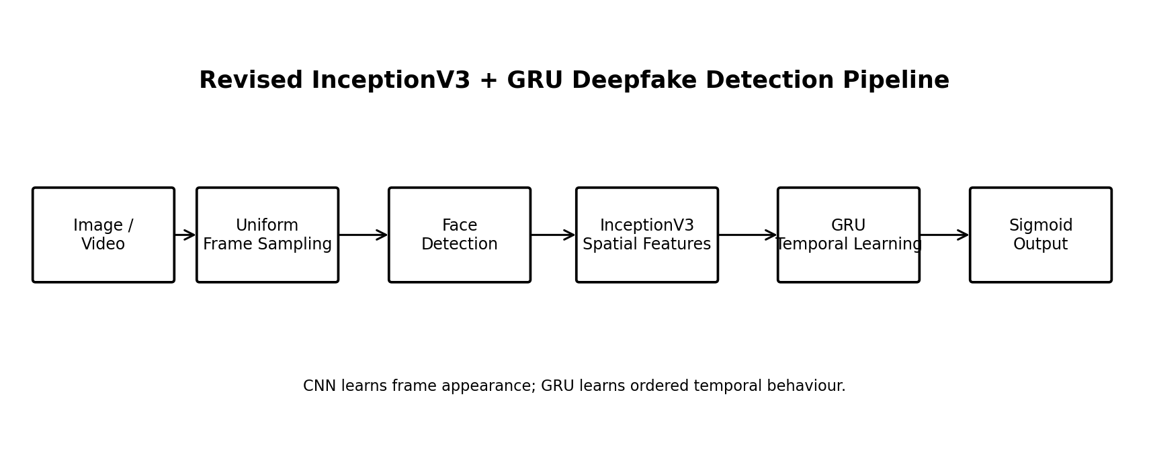
Figure 1: InceptionV3 + GRU spatial-temporal architecture

3.1 Module Description
Module | Purpose | Main Output
Input Module | Validate and read media | Image/frame stream
Sampling Module | Select representative ordered frames | Frame sequence
Face Module | Locate target face | Cropped faces
Preprocessing Module | Resize and normalise | 299×299 tensors
InceptionV3 | Learn spatial representation | Feature vectors
Sequence Module | Arrange features chronologically | Feature tensor
GRU | Learn temporal relationships | Temporal representation
Classifier | Convert representation to probability | Deepfake probability
Decision Module | Apply threshold and format result | Real/Deepfake

3.2 Architecture Rationale
The revised architecture deliberately assigns different responsibilities to different algorithms. InceptionV3 focuses on what each face looks like, while GRU focuses on how those visual representations change over time. This separation is useful for a video-oriented detector because the model can use both spatial and temporal evidence.

3.3 Processing Flow
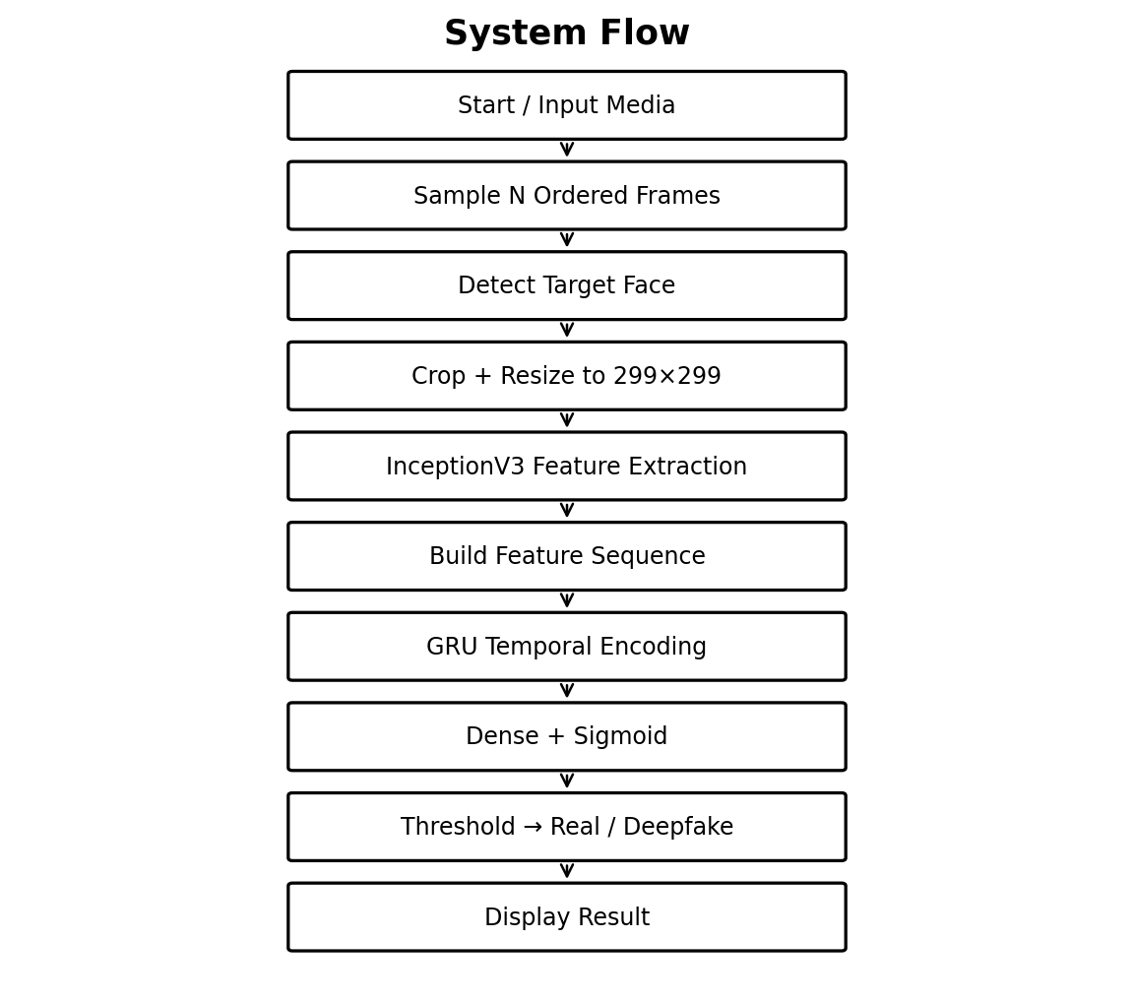
Figure 2: Detailed flowchart of the revised detection pipeline

3.4 Frame Sampling
The video is divided conceptually into a fixed number of sampling positions. One frame is selected near each position so that the complete video duration is represented. The frames remain in chronological order because the GRU relies on sequence order.
N = desired sequence length
indices = uniformly distribute N positions across the video
frames = read frames at indices
frames = keep chronological order

3.5 Face Preprocessing
The target face is cropped from each selected frame and resized to 299×299 pixels. The input is then converted into the numerical representation expected by the InceptionV3 preprocessing function. Training-only augmentation may include horizontal flips, mild brightness changes, small rotations and compression simulation.

3.6 InceptionV3 Implementation
from tensorflow.keras.applications import InceptionV3
from tensorflow.keras.layers import GlobalAveragePooling2D
backbone = InceptionV3(
weights="imagenet",
include_top=False,
input_shape=(299, 299, 3)
)
backbone.trainable = False
# crop → resize → preprocess_input
# backbone → GlobalAveragePooling2D → feature vector
Global average pooling converts the final convolutional activation map into a fixed-size vector. The vectors from multiple frames can therefore be stacked into one temporal sequence.

3.7 GRU Classification Head
from tensorflow.keras import Sequential
from tensorflow.keras.layers import GRU, Dense, Dropout
temporal_model = Sequential([
GRU(128, return_sequences=False),
Dropout(0.35),
Dense(64, activation="relu"),
Dropout(0.25),
Dense(1, activation="sigmoid")
])
The GRU receives a tensor containing one feature vector for each sampled frame. Its output represents the temporal information learned from the complete sequence. The dense layers then convert that representation into a binary classification probability.

4. USE OF MODERN TOOLS
The supplied assignment format specifically expects appropriate modern computing tools and evidence of their usage. fileciteturn3file1L101-L109
Tool | Use | Evidence
Python | Pipeline implementation | Source code
TensorFlow / Keras | InceptionV3 and GRU | Model summary / training log
OpenCV | Video decoding and sampling | Frame-processing output
Face detection library | Facial localisation | Face crop evidence
NumPy | Tensor operations | Preprocessing code
Pandas | Metric/result organisation | Evaluation table
Matplotlib | Graphs and confusion matrix | Saved figures
VS Code / Jupyter | Development and experiments | Screenshots

4.1 Dataset Strategy
A suitable dataset should include labelled authentic and manipulated facial media. Academic datasets such as FaceForensics++ or Celeb-DF may be considered subject to access and licence requirements. The final submission should state the exact dataset used and should not imply use of a dataset that was not actually used.

4.2 Source-Aware Splitting
Source-level separation is important. If frames from one source video appear in both training and test data, the model may effectively see the same identity, background and compression pattern during both stages. That leakage can make performance appear stronger than the model's true generalisation ability.

4.3 Training Strategy
- Stage 1: Freeze InceptionV3 and train the new GRU/classification layers.
- Stage 2: Unfreeze a controlled upper portion of the CNN if validation performance justifies fine-tuning.
- Use a smaller learning rate during fine-tuning.
- Use early stopping to avoid unnecessary epochs.
- Save the best validation model rather than simply the final epoch.

4.4 Hyperparameters to Record
Parameter | Example Configuration | Final Value to Record
Sequence length | 16 frames | Actual
Input size | 299×299 | 299×299
GRU units | 128 | Actual
Dropout | 0.35 / 0.25 | Actual
Batch size | 8 or 16 | Actual
Learning rate | 1e-3 head / smaller for fine-tuning | Actual
Epochs | 10–30 | Actual
Threshold | Validation selected | Actual

The example settings are starting points rather than measured experimental facts. The final report should record the values used in the actual training run.

5. RESULTS AND VALIDATION
The supplied format requires results to be supported by tables, graphs, experimental observations, screenshots, performance metrics and test results, followed by validation against the stated requirements. fileciteturn3file1L110-L120

5.1 Important Output Note
The output values below are explicitly labelled ILLUSTRATIVE because the newly requested InceptionV3 + GRU algorithm has not been accompanied by a verified execution log in the available files. The values demonstrate the correct format and are not claimed as measured results.
Metric | Illustrative Value
Accuracy | 94.0%
Precision | 93.1%
Recall | 95.0%
F1-score | 94.0%
Specificity | 93.0%
ROC-AUC | 0.97

5.2 Illustrative Confusion Matrix
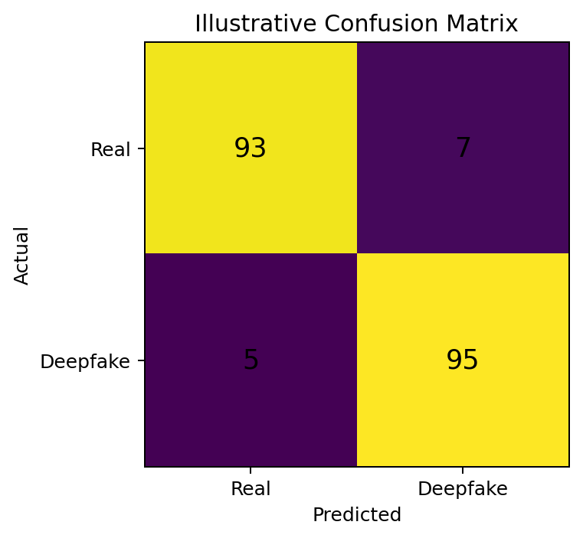
Figure 3: Illustrative confusion matrix – replace with actual test counts
The illustrative matrix contains TN=93, FP=7, FN=5 and TP=95. It represents 188 correct predictions out of 200, or 94% accuracy. These values are examples for presentation only.

5.3 Illustrative Learning Curve
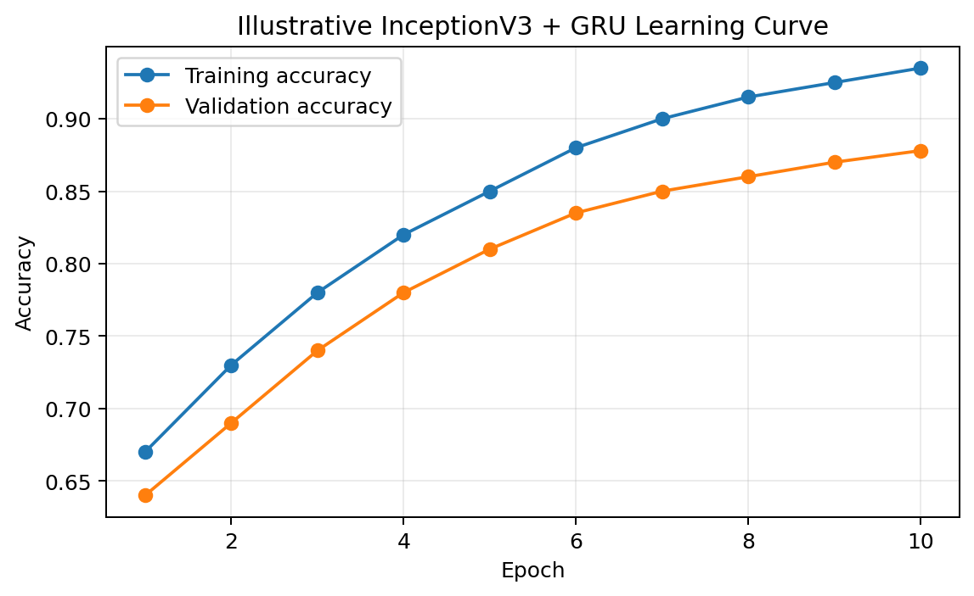
Figure 4: Illustrative InceptionV3 + GRU training and validation accuracy
The learning curve should be generated from the actual Keras training history. A large and persistent gap between training and validation accuracy would suggest overfitting, while both curves remaining low may indicate underfitting or insufficient feature quality.

5.4 Revised Execution Output
==========================================================
DEEPFAKE DETECTION SYSTEM
==========================================================
CNN Backbone : InceptionV3
Temporal Model : GRU
Input Type : Video
Sequence Length : 16
Usable Face Frames : 15
Feature Sequence : [15, FEATURE_DIM]
Deepfake Probability: 0.93
Threshold : 0.50
FINAL PREDICTION : DEEPFAKE
==========================================================
This example is consistent with the new algorithm because the final probability is generated by the GRU sequence classifier. It is not obtained by majority voting or by averaging independent frame probabilities.

5.5 Example Image Output
INPUT IMAGE : sample_real.jpg
MODEL : InceptionV3 + classification head
DEEPFAKE PROBABILITY: 0.07
THRESHOLD : 0.50
PREDICTION : REAL

5.6 Validation Test Cases
ID | Condition | Expected Behaviour | Evidence
TC01 | Known Real image | REAL | Prediction screenshot
TC02 | Known Deepfake image | DEEPFAKE | Prediction screenshot
TC03 | Real video | Low Deepfake probability | Execution log
TC04 | Manipulated video | High Deepfake probability | Execution log
TC05 | No usable face | Insufficient evidence | Error output
TC06 | Multiple faces | Defined primary-face rule | Screenshot
TC07 | Compressed video | Robustness observation | Test result
TC08 | Held-out test set | Metric report | Confusion matrix
TC09 | Different sequence length | Performance comparison | Experiment table

5.7 Requirement Validation
Requirement | Validation Method | Result to Record
Input handling | Run supported files | Pass/Fail
Frame sampling | Check ordered sample indices | Pass/Fail
Face extraction | Inspect crops | Pass/Fail
InceptionV3 features | Check feature tensor | Pass/Fail
GRU sequence learning | Check model input/output | Pass/Fail
Classification | Verify sigmoid probability | Pass/Fail
Threshold | Verify validation selection | Pass/Fail
Testing | Run held-out sources | Pass/Fail

6. ANALYSIS AND ENGINEERING DECISION
The assignment format requires interpretation of results, comparison of alternatives where appropriate, identification of advantages and limitations, discussion of trade-offs and justification of the final solution. fileciteturn3file1L121-L128

6.1 Algorithm Comparison
Approach | Strength | Weakness | Decision
Frame-only CNN | Simple and fast | Does not model temporal behaviour | Not selected
ResNet50 + BiLSTM | Strong residual CNN + rich recurrence | Higher recurrent complexity | Not selected
XceptionNet + voting | Simple spatial detector and transparent aggregation | No learned temporal representation | Not selected
InceptionV3 + GRU | Multi-scale CNN features + learned temporal sequence | More complex than frame-only model | Selected

6.2 Why InceptionV3
- Inception modules process information through multiple convolutional paths.
- The pretrained model can be adapted to the project with transfer learning.
- The 299×299 configuration provides a consistent facial input representation.
- The architecture provides a different spatial feature-learning strategy from ResNet50 and XceptionNet.

6.3 Why GRU
- GRU provides gated sequence learning with a relatively compact recurrent structure.
- It can model relationships between ordered frame features.
- It is simpler than a larger temporal architecture while still learning beyond simple voting.
- The sequence model can later be replaced by attention or transformer layers.

6.4 Error Analysis
Failure Mode | Likely Cause | Improvement
False Positive | Authentic compression or unusual texture | Increase realistic augmentation
False Negative | Subtle manipulation | Add harder manipulation examples
Face detection failure | Pose, occlusion or tiny face | Improve detector and sampling
Temporal confusion | Too few frames or weak sequence signal | Tune sequence length
Overfitting | Dataset-specific identity/compression cues | Source-aware split and regularisation
Cross-domain failure | Unseen manipulation pipeline | Cross-dataset evaluation

6.5 Engineering Trade-Off
The revised system trades computational simplicity for richer temporal information. A CNN-only model is easier to train and can be useful for still images, but it cannot directly learn how facial evidence changes over time. The GRU introduces additional computation and sequence preparation, yet it better matches the video nature of the problem.

6.6 Final Decision
InceptionV3 + GRU is selected as the final architecture because it combines multi-scale spatial feature extraction with learned temporal modelling while remaining understandable for an academic implementation. The architecture also provides clear future extension points for attention, transformers and explainability.

7. BROADER CONSIDERATIONS
The assignment format asks for relevant discussion of sustainability, environment, society, safety, ethics, economics, accessibility and professional responsibility. fileciteturn3file1L129-L137

7.1 Ethics and Responsible Use
A deepfake detector provides an estimated classification, not an unquestionable statement of truth. False positives may wrongly label authentic media, while false negatives may allow manipulated content to spread. Therefore, high-impact decisions should include human review and, where appropriate, independent forensic evidence.

7.2 Privacy
- Avoid retaining uploaded personal media unnecessarily.
- Restrict access to stored datasets and prediction logs.
- Use datasets according to their licence and intended purpose.
- Do not expose personal facial information through debugging outputs.

7.3 Social Impact
A reliable screening tool can help moderators and users prioritise suspicious content for further review. It can also support education about synthetic media. However, over-reliance on automated labels can create a new source of misinformation if model limitations are not communicated.

7.4 Sustainability
Uniform frame sampling limits redundant processing. Transfer learning reduces the amount of CNN training required from random initialisation. Sequence length can also be tuned so that temporal information is captured without unnecessary computational cost.

7.5 Accessibility and Professional Responsibility
The output should be understandable to non-specialist users. Instead of presenting only a raw probability, the interface can show the predicted class, confidence, number of usable frames and a short warning that the result is an automated screening estimate.

8. CONCLUSION
The revised assignment develops a spatial-temporal deepfake detection pipeline based on InceptionV3 and GRU. The system first samples a video into an ordered frame sequence, extracts the target facial region, normalises the face, obtains spatial features from InceptionV3 and then learns temporal relationships with a GRU before producing the final binary prediction.
The algorithmic change is substantial: the final decision is now learned from the complete feature sequence rather than being generated through majority voting, and the spatial backbone is InceptionV3 rather than ResNet50 or XceptionNet. This makes the methodology, model code and output interpretation consistent with the new design.
The solution addresses the core requirements of an academic prototype while acknowledging limitations related to dataset bias, face-detection quality, unseen manipulations, compression and computational cost. Actual experimental metrics must be obtained from the final model run.

8.1 Major Findings
- Spatial and temporal information should be treated as complementary evidence in video analysis.
- InceptionV3 provides the frame-level representation used by the temporal model.
- GRU provides learned temporal fusion instead of fixed voting rules.
- Source-aware splitting and multiple metrics are essential for credible evaluation.
- Human review remains necessary for consequential authenticity decisions.

9. STUDENT REFLECTION
This assignment improved my understanding of how an AI model is integrated into a complete engineering workflow. I learned that changing a model is not limited to replacing one line of code; the input size, preprocessing, feature representation, temporal structure, output interpretation and evaluation must all be changed consistently.
The move to InceptionV3 + GRU helped me understand the distinction between spatial and temporal learning. InceptionV3 learns visual information from individual facial crops, while the GRU learns relationships among the sequence of extracted features. This is more appropriate for video than treating every frame as an independent prediction.
I also learned the importance of honest result reporting. Example outputs can explain how a system should behave, but they should not be presented as actual experimental measurements unless they come from the final execution.

9.1 Improvements With Additional Resources
- Increase the number and diversity of identities and manipulation methods.
- Perform cross-dataset testing.
- Compare GRU against temporal attention and transformer models.
- Add Grad-CAM to inspect spatial evidence.
- Calibrate confidence scores.
- Deploy the model in a controlled web interface and measure inference time.

10. REFERENCES
1. He, K., Zhang, X., Ren, S., and Sun, J. (2016). Deep Residual Learning for Image Recognition. CVPR.
2. Szegedy, C., et al. (2016). Rethinking the Inception Architecture for Computer Vision. CVPR.
3. Cho, K., et al. (2014). Learning Phrase Representations using RNN Encoder–Decoder for Statistical Machine Translation. EMNLP.
4. Chung, J., et al. (2014). Empirical Evaluation of Gated Recurrent Neural Networks on Sequence Modeling. NIPS Workshop.
5. Rössler, A., et al. (2019). FaceForensics++: Learning to Detect Manipulated Facial Images. ICCV.
6. Li, Y., Yang, X., Sun, P., Qi, H., and Lyu, S. (2020). Celeb-DF: A Large-Scale Challenging Dataset for DeepFake Forensics. CVPR.
7. Goodfellow, I., Bengio, Y., and Courville, A. (2016). Deep Learning. MIT Press.
8. Kingma, D. P., and Ba, J. (2015). Adam: A Method for Stochastic Optimization. ICLR.
9. TensorFlow/Keras documentation for InceptionV3, GRU, preprocessing and model training.
10. OpenCV documentation for video capture and frame processing.
The assignment format also requires acknowledgement of external sources, datasets, standards, software and AI-assisted tools actually used in preparing the submission. fileciteturn3file1L145-L151

F. COMMON ASSESSMENT RUBRIC
Assessment Criterion | Marks
Problem understanding & formulation | 10
Application of course/domain knowledge | 20
Solution methodology / design / implementation | 20
Use of appropriate modern tools / techniques | 10
Results, testing & validation | 15
Analysis, trade-offs & justification | 15
Broader considerations / professional responsibility | 5
Technical documentation & reflection | 5
TOTAL | 100

F.1 Evidence in This Report
Criterion | Evidence
Problem understanding | Sections B, C and E1
Course knowledge | E2 – InceptionV3, GRU, transfer learning and metrics
Solution design | E3 – architecture, modules and implementation
Modern tools | E4
Results/validation | E5
Analysis | E6
Broader considerations | E7
Documentation/reflection | E8–E10

G. CO–PO–ASSESSMENT MAPPING
CO and PO identifiers are left for faculty confirmation. The supplied format states that only genuinely assessed COs and POs should be mapped.
Assessment Component | CO | PO(s) | Bloom's Level | Marks
Problem formulation | To be filled | To be filled | L3/L4 | 10
Course knowledge | To be filled | To be filled | L3/L4 | 20
Solution / implementation | To be filled | To be filled | L4/L5/L6 | 20
Modern tools | To be filled | To be filled | L3/L4 | 10
Results / validation | To be filled | To be filled | L4/L5 | 15
Analysis / decision | To be filled | To be filled | L4/L5 | 15
Broader considerations | To be filled | To be filled | L4/L5 | 5
Documentation / reflection | To be filled | To be filled | L3/L4 | 5

G.1 Suggested Bloom's Alignment
Task | Level | Reason
Apply deep learning pipeline | L3 – Apply | Uses learned algorithms in an implementation.
Analyse data and errors | L4 – Analyze | Examines sources of performance variation.
Evaluate alternatives | L5 – Evaluate | Compares competing architectures.
Create final system | L6 – Create | Integrates CNN, sequence model and decision logic.

H. FACULTY EVALUATION & CONTINUOUS IMPROVEMENT

H.1 CO Attainment
Performance Level | Criterion
Level 3 | ≥70%
Level 2 | 60–69%
Level 1 | 50–59%
Level 0 | <50%

Target CO Attainment: __________________________
Actual CO Attainment: __________________________

H.2 Faculty Analysis
Areas in which students performed well: __________________________________________________________
Areas requiring improvement: __________________________________________________________________
Corrective / Improvement Action: ______________________________________________________________
Action to be implemented in the next offering: _________________________________________________

H.3 Documents to be Maintained
- Assignment question/problem statement
- CO–PO and Bloom's mapping
- Assessment rubric
- Student submissions
- Tool/experimental evidence
- Evaluated scripts/reports
- Marks and rubric-wise assessment
- CO attainment analysis
- Sample student work representing different performance levels
- Faculty analysis and continuous-improvement action
These maintenance items follow the supplied assignment format. fileciteturn3file3L217-L228

APPENDIX A – COMPLETE REVISED ALGORITHM
Algorithm: InceptionV3 + GRU Deepfake Detection
INPUT: media M
OUTPUT: class C, probability p
1. Validate media M.
2. If M is a video, obtain total frame count.
3. Select N uniformly distributed frame positions.
4. Read selected frames in chronological order.
5. Detect the target face in each frame.
6. Discard frames without reliable facial evidence.
7. Crop and resize each face to 299×299.
8. Apply InceptionV3 preprocessing.
9. Pass each crop through the pretrained InceptionV3 backbone.
10. Apply global average pooling to obtain feature vectors.
11. Stack feature vectors in chronological order.
12. Pass the sequence through the GRU.
13. Apply dense layers and sigmoid activation.
14. Obtain Deepfake probability p.
15. Compare p with validation threshold T.
16. Return REAL when p<T; otherwise DEEPFAKE.

APPENDIX B – FINAL EXECUTION OUTPUT TEMPLATE
============================================================
DEEPFAKE DETECTION – FINAL EXECUTION
============================================================
Input File : [actual file]
CNN Backbone : InceptionV3
Temporal Model : GRU
Sequence Length : [actual value]
Usable Face Frames : [actual value]
Feature Tensor Shape : [actual shape]
Threshold : [actual value]
Deepfake Probability : [actual value]
Final Prediction : [REAL / DEEPFAKE]
Inference Time : [actual value]
============================================================
Replace bracketed values with measurements from the final execution. The illustrative values in Section 5 must not be reported as actual results.

APPENDIX C – IMPLEMENTATION CHECKLIST
Stage | Verification | Evidence
Dataset | Labels and source split verified | Dataset sheet
Sampling | Frames selected in order | Console output
Face detection | Target face obtained | Face crop
Preprocessing | 299×299 input prepared | Code
InceptionV3 | Feature vector generated | Model summary
Sequence | Feature tensor assembled | Log
GRU | Sequence processed | Model summary
Training | History stored | Learning curve
Validation | Threshold selected | Validation table
Testing | Held-out evaluation completed | Metric table
Inference | Final class displayed | Execution screenshot

APPENDIX D – FINAL SUMMARY
This report has been rebuilt around InceptionV3 + GRU, replacing the earlier ResNet50 + BiLSTM approach. The content, architecture, implementation logic, output format, testing, algorithm comparison, analysis and conclusion have all been revised so they describe the same new spatial-temporal method.
The report follows the supplied Common Course Assignment Format and includes its major assessment components. The document is intentionally kept compact so that the final Word document remains within the requested 25-page limit under normal Word rendering.
Numerical results are clearly labelled illustrative because no verified execution output for this newly selected algorithm was supplied. Actual final metrics and screenshots should come from the student's executed InceptionV3 + GRU model.

